Statistical Communiqué on the National Economy and Social Development of Beijing in 2023[1]
Beijing Municipal Bureau of Statistics
NBS Survey Office in Beijing
March 2024

2023 was the first year of the full implementation of the guiding principles of the 20th CPC National Congress. It was also a year of economic recovery following the change in approach to COVID-19. In the face of internal and external risks and challenges, and under the strong leadership of the CPC Central Committee with Comrade Xi Jinping as the core, the Beijing Municipality upheld Xi Jinping Thought on Socialism with Chinese Characteristics for a New Era, fully implemented the guiding principles of the 20th CPC National Congress and the Second Plenary Session of the 20th CPC Central Committee, thoroughly implemented the guiding principles of General Secretary Xi Jinping’s series of important speeches relating to Beijing, and conscientiously put into practice the decisions and plans of the Party Central Committee. We adhered to the underlying principles of pursuing progress while ensuring stability, and applied the new development philosophy in full, in the right way, and in all fields of endeavor. We have simultaneously enhanced our work on the following five aspects (i.e. turning Beijing into an international science and technology innovation center, robustly developing the Integrated National Demonstration Zone for Opening up the Services Sector as well as the China (Beijing) Pilot Free Trade Zone, building Beijing into a digital benchmark city, creating new demands for development through supply-side structural reforms, and driving Beijing-Tianjin-Hebei coordinated development), fostered the new development paradigm, and focused on making best efforts to boost confidence, strengthen innovation, optimize functions, promote synergy, work on governance, and benefit the people’s livelihood, so that the overall economy continued to recover, people’s living standards were effectively guaranteed, and steady progress was made towards high-quality development of Beijing.

I. Overview
Based on preliminary accounting, the gross domestic product (GDP) of Beijing hit RMB 4,376.07 billion in 2023, up by 5.2% over the previous year at constant price. Of which the achieved added value of the Primary Industry[2] was RMB 10.55 billion with a decline of 4.6%, that of the Secondary Industry was RMB 652.56 billion with a growth of 0.4% and that of the Tertiary Industry was RMB 3,712.96 billion with a growth of 6.1%. The ratio of the Primary Industry, the Secondary Industry and the Tertiary Industry was 0.2:14.9:84.8. Calculated by permanent population, the per capita GDP of Beijing totaled RMB 200 thousands.
Table 1: GDP in 2023
Indicators | Absolute volume  (RMB 100 million) | Increase over the previous year (%) | Proportion (%)
GDP | 43760.7 | 5.2 | 100.0
Grouped by Industry
Primary Industry | 105.5 | -4.6 | 0.2
Secondary Industry | 6525.6 | 0.4 | 14.9
Tertiary Industry | 37129.6 | 6.1 | 84.8
Grouped by Sector
Agriculture, Forestry, Animal Production and Hunting, Fishing | 106.9 | -4.6 | 0.2
Industry | 5008.5 | 0.3 | 11.4
Construction | 1603.4 | 0.8 | 3.7
Wholesale and Retail Trades | 3073.1 | -0.9 | 7.0
Transport, Storage and Post | 1065.3 | 20.3 | 2.4
Accommodation and Restaurants | 453.1 | 21.1 | 1.0
Information Transmission, Software and Information Technology Services | 8514.4 | 13.5 | 19.5
Finance | 8663.1 | 6.7 | 19.8
Real Estate | 2612.0 | 2.3 | 6.0
Renting and Leasing Activities and  Business Services | 2710.0 | 4.0 | 6.2
Scientific Research and Development,  Technical Services | 3630.1 | 3.4 | 8.3
Management of Water Conservancy,  Environment and Public Facilities | 307.0 | 1.1 | 0.7
Resident Services, Repair and Other  Services | 208.2 | 2.9 | 0.5
Education | 1954.8 | 0.5 | 4.5
Health Care and Social Works | 1290.0 | 2.1 | 2.9
Culture, Sports and Entertainment | 836.1 | 4.3 | 1.9
Public Administration, Social Security  and Social Organizations | 1724.8 | 0.5 | 3.9

Figure 1: Gross Domestic Product and Growth Rates from 2019 to 2023
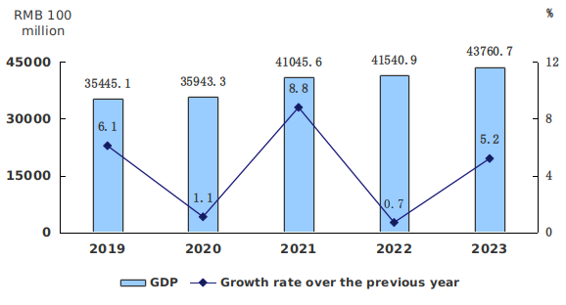
At the end of 2023, the permanent population[3] was 21.858 million, an increase of 15 thousands over the end of the previous year. Of which, the urban population reached 19.198 million, accounting for 87.8% of the total permanent population; the migrant population was 8.240 million, accounting for 37.7% of the total permanent population. The birth rate of permanent population was 5.63‰, the death rate was 6.13‰, and the natural rate of growth was -0.5‰. Number of newly increased employment in urban regions in 2023 hit 281 thousands, and the average surveyed unemployment rate in urban regions was 4.4%.
Table 2: Population and Its Composition by the End of 2023
Indicators | Population by the end of the year (10,000 persons) | Proportion (%)
Permanent Population | 2185.8 | 100.0
Grouped by area: Urban | 1919.8 | 87.8
Rural | 266.0 | 12.2
Grouped by gender: Male | 1113.3 | 50.9
Female | 1072.5 | 49.1
Grouped by age: Aged 0-14 | 262.5 | 12.0
Aged 15-59 | 1428.5 | 65.4
Aged 60 and above | 494.8 | 22.6
Of which: Aged 65 and above | 346.9 | 15.9
Overall consumer price went up by 0.4% over the previous year. Producer price for industrial products declined by 0.8% and purchasing price for industrial products declined by 1.3%. The producer price for agricultural products declined by 0.3%. In December, the month-on-month index of sales price of new commercial housing was 100.0 and the year-on-year index was 101.7; the month-on-month index of sales price of second-hand housing was 98.8 and the year-on-year index was 97.8.
Figure 2: Monthly Changes in Consumer Price in 2023
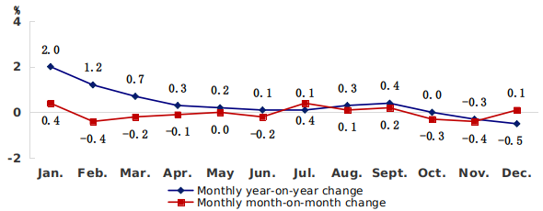
Table 3: Changes in Consumer Price in 2023
Indicators | Change over the previous year (%)
Consumer price | 0.4
Food, Tobacco and Alcohol | 0.1
Of which: Food | -1.0
Of which: Grain | -0.4
Pork | -14.3
Fresh vegetables | -6.9
Eggs | -0.7
Clothing | 0.6
Housing | 0.3
Household Goods and Services | 0.3
Transportation and Communication | -1.7
Education, Culture and Entertainment | 2.8
Healthcare | 0.2
Other Supplies and Services | 4.2

Table 4: Month-on-Month Index of Sales Prices of New Commercial Housing and Second-hand Housing in 2023

Index  (Previous month = 100) | Jan. | Feb. | Mar. | Apr. | May | Jun. | Jul. | Aug. | Sept. | Oct. | Nov. | Dec.
New commercial housing | 100.4 | 100.2 | 100.3 | 100.6 | 100.2 | 100.1 | 100.4 | 99.8 | 100.4 | 99.6 | 99.9 | 100.0
Second-hand housing | 100.9 | 100.8 | 100.7 | 100.1 | 99.4 | 99.3 | 99.4 | 100.4 | 100.7 | 98.9 | 98.6 | 98.8
In 2023, the general public budgetary revenue amounted to RMB 618.11 billion, up by 8.2% over the previous year. Of which, the tax revenue amounted to RMB 535.71 billion, up by 10.1%. The general public budgetary expenditures of Beijing totaled RMB 797.16 billion, up by 6.7% over the previous year. The cumulative new amount of tax and fee reductions, tax rebates and fee deferrals in 2023 totaled RMB 97.17 billion.
New growth drivers were gaining ground. With the aim of building Beijing into a global benchmark city for digital economy, the added value of digital economy reached RMB 1,876.67 billion in 2023, up by 8.5% over the previous year at current price, which accounted for 42.9% of the GDP, up by 1.3 percentage points over the previous year. Of which, the added value of core industries of digital economy stood at RMB 1,106.15 billion, up by 10.8%, which accounted for 25.3% of the GDP, up by 1.3 percentage points. The added value of high-tech industry reached RMB 1,187.54 billion in 2023, up by 7.1% at current price, which accounted for 27.1% of the GDP, up by 0.4 percentage points. A total of 123 thousands science and technology enterprises were newly established in 2023, up by 15.9%, which accounted for 41.4% of the newly established enterprises in Beijing.
Economic vitality continued to increase. The reform tasks were launched in the Reform Plan on Optimizing the Business Environment of Beijing Version 6.0, the action plan on the implementation of Opinions on “Beijing Service” and promotion of development and growth of private economy was made, and the mechanisms of “Service Packages” and “Service Steward” were improved. In 2023, Beijing saw 297 thousands newly established businesses, up by 20.3% over the previous year. Output value of “specialized and new” industrial enterprises above designated size and revenue of service enterprises above designated size grew by 5.2% and 6.1% respectively over the previous year, with the growth rate being higher than the average level of the industrial and service enterprises above designated size by 2.6 percentage points and 4.1 percentage points respectively.
Green transition was further promoted. In 2023, the production of renewable energy saw sustained improvement. Among the installed generating capacity in Beijing, the proportion of installed capacity of renewal energy generation was 20.4%, up by 1.3 percentage points over the previous year; electricity generated from biomass energy, hydroenergy, solar energy, wind energy and other renewable energies accounted for 10.8% of the total electricity generation. Water consumption in areas with GDP of RMB 10,000 was 9.30 m³, down by 3.33% over the previous year at constant price.
In-depth and practical results were achieved in Beijing-Tianjin-Hebei coordinated development. In 2023, 112 general manufacturers were relocated for quality improvement, and 23.15 million square meters of illegal construction were dealt with. The investment in the construction of Beijing’s sub-center stood at RMB 100 billion; the second batch of municipal-level organs had been relocated; Beijing Art Center, Beijing Library, and Beijing-Hangzhou Grand Canal Museum were completed and put into use. The Integrated Service Hall of Beijing Municipal Administrative Center Government Service Center was inaugurated for operation in Dachang County of Hebei Province and in Wuqing District of Tianjin, taking the lead in realization of the cross-region handling of government services in China. Collaborative innovation was strengthened and industrial cooperation became closer, the Jingjinji National Center of Technology Innovation was jointly established by Beijing, Tianjin and Hebei, and six key industrial chain knowledge graphs were formulated. Zhongguancun Science Park in Xiong’an New Area was inaugurated for operation, where more than 30 innovative enterprises and 11 Zhongguancun integrated service agencies settled.
II. Agriculture
The gross output of agriculture, forestry, animal production and hunting, fishing reached RMB 25.25 billion in 2023, down by 4.6% over the previous year at comparable price. Of which, the output value of agriculture (planting industry) reached RMB 13.56 billion, up by 5.1%; that of forestry reached RMB 6.59 billion, down by 20.6% due to the high base as a result of the ending of the new round of million mu afforestation project. The sewn area of grain crops totaled 89 thousands hectares, up by 16.6%, the gross output of grain totaled 478 thousands tons, up by 5.3%; the output of vegetables and edible mushrooms totaled 2.075 million tons, up by 4.3%; the pig stock by the end of 2023 was 267 thousands, and the number of slaughtered pigs was 329 thousands. The sewn area of facility agriculture totaled 476 thousands mu, with realized output value of RMB 6.04 billion, increasing by 1.0%. The number of agricultural sightseeing gardens registered 1,044, with realized total income of RMB 2.12 billion, increasing by 1.7% and 15.4% respectively. There were 7,738 rural tourism households and units that were in actual operation, with realized total income of RMB 1.50 billion, increasing by 8.9% and 9.1% respectively.
The project of “Hundred Village Demonstration and Thousand Village Revitalization” was initiated for implementation. The cultivated land protection system was strictly implemented, and 57 thousands mu of high-standard farmland was built, and at the same time, efficient water-saving irrigation was completed for 41 thousands mu. Innovation in agricultural science and technology was promoted: three sub-centers of Jingwa Agricultural Science & Technology Innovation Center were placed in operation. Integrated development of industries was promoted: the number of the key leading enterprises of agricultural industrialization^{[4]} totaled 120, of which, 74 were municipal-level ones and 46 were national-level ones; the number of green food enterprises engaged in local agricultural products within the validity period^{[5]} in Beijing totaled 77, with 389 products, and the output of green organic agricultural products increased by 21.0%; and there were 16 newly-added municipal-level demonstration farmers’ cooperatives and 203 demonstration family farms. The rural living environment was improved: the construction of beautiful countryside was finished in more than 2,800 villages, the coal-to-clean energy project was finished in 2,946 villages.
III. Industry and Construction
The industrial added value of 2023 was RMB 500.85 billion, with an increase of 0.3% over the previous year at constant price. Of which, the added value of industries above designated size[6] rose by 0.4%. Thereinto, the added value of production and supply of electric power and heat power rose by 7.9%, that of manufacture of five major equipment[7] rose by 10.6%, that of manufacture of motor vehicles rose by 5.2%,that of manufacture of computer, communication equipment and other electronic equipment fell by 0.9%,and that of manufacture of medicines fell by 21.7% (eliminating the factor of COVID-19 vaccine production). The sales value of industrial enterprises above designated size was RMB 2,311.36 billion, up by 2.9%. Of which, the domestic sales value reached RMB 2,134.27 billion, up by 3.4%; the delivery value of export hit RMB 177.09 billion, down by 2.5%. Among the production of the products in high-end or emerging fields, the output of wind turbine generator systems, LCD modules, new energy vehicles, medical equipment and appliances increased by 68.8%, 39.2%, 35.6% and 26.7% respectively.
Figure 3: Industrial Added Value and Growth Rates from 2019 to 2023
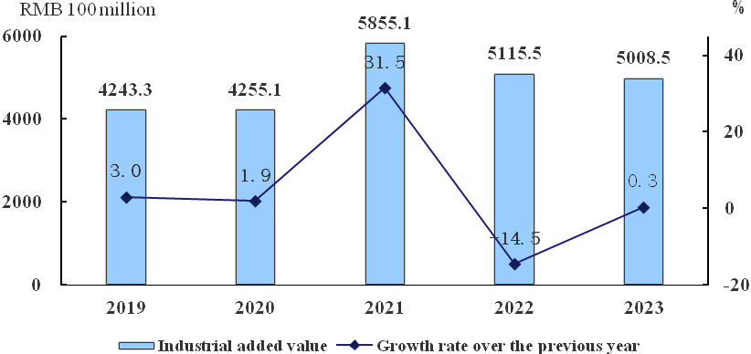
Table 5: Growth Rates of Added Value of Main Monitored Sectors of Industries above Designated Size in 2023
Unit: %
Sectors | Increase over the previous year | Proportion
Added Value of Industries above Designated Size | 0.4 | 100.0
Of which: Processing of Petroleum, Coal and other  Fuels | 1.1 | 2.4
Manufacture of Chemical Raw Materials  and Chemical Products | -6.5 | 3.5
Manufacture of Medicines | -21.7 | 11.3
Manufacture of Non-metallic Mineral  Products | 0.03 | 1.5
Manufacture of General-purpose  Machinery | -7.1 | 3.8
Manufacture of Special-purpose  Machinery | 17.1 | 6.8
Manufacture of Motor Vehicles | 5.2 | 14.2
Manufacture of Railway Locomotives,  Building of Ships and Boats,  Manufacture of Air and Spacecrafts and  other Transportation Equipment | 16.8 | 2.1
Manufacture of Electrical Machinery and  Equipment | 25.3 | 4.6
Manufacture of Computer,  Communication Equipment and other  Electronic Equipment | -0.9 | 10.9
Manufacture of Measuring Instrument  and Meter | -2.8 | 2.3
Production and Supply of Electric Power  and Heat Power | 7.9 | 20.8

Table 6: Major Product Output of Industrial Enterprises above Designated Size in 2023
Product | Unit | Output | Increase over the previous year (%)
Fresh, Chilled Meat | 10,000 tons | 47.5 | -4.4
Dairy Products | 10,000 tons | 49.0 | 0.2
Beverage and Alcohol | 10,000 KL | 137.7 | 6.6
Raw Medicine of Chemical Medicines | 10,000 tons | 1.3 | -21.4
Finished Traditional Chinese Herbal Medicine | 10,000 tons | 4.5 | 0.7
Machine-tools for Cutting Metal | Set | 5732 | -14.0
Of which: Digitally-controlled  Machine-tools for Cutting Metal | Set | 5351 | -13.5
Medical Equipment and Appliances | Set | 150753 | 26.7
Industrial Robot | Set | 3116 | -20.3
Automobile | 10,000 units | 100.3 | 8.1
Of which: Basic Car | 10,000 units | 49.6 | 6.7
SUV | 10,000 units | 43.5 | 6.7
Of which: New Energy Vehicle | Unit | 76900 | 35.6
Wind Turbine Generator Systems | 10,000 KW | 1085.8 | 68.8
Finished Electronic Computers | 10,000 units | 618.4 | -28.2
Of which: Micro-computer Equipment | 10,000 units | 615.8 | -28.3
Display | 10,000 units | 213.8 | -8.4
Mobile Telephone (cell phone) | 10,000 units | 10286.8 | 8.9
Integrated Circuit | 100 million units | 211.4 | -3.1
Photoelectronic Components | 100 million units | 5.1 | -27.0
LCD Module | 10,000 sets | 20437.8 | 39.2
Electronic Components | 10,000 sets | 25.3 | 26.9
Industrial Automatic Regulating Instrument and Control System | Unit (Set) | 811080 | 9.7
Analysis Instruments and Devices | Unit (Set) | 1460138 | -10.2
The realized operating revenue of industrial enterprises above designated sized in Beijing hit RMB 2,780.79 billion, up by 3.6% over the previous year; the total realized profit registered RMB 169.23 billion, down by 12.9%. The profit margin of operating revenue of industrial enterprises above designated size was 6.09%, down by 1.15 percentage points over the previous year.
The gross output value made by construction enterprises qualified for general contracts and specialized contracts registered RMB 1,427.25 billion in 2023, up by 4.0% over the previous year. Of which, RMB 395.11 billion was achieved in Beijing, up by 4.3%; RMB 1,032.14 billion was gained in other provinces, up by 3.9%. The newly-signed contracts in 2023 valued RMB 2,009.92 billion, down by 0.6%.

IV. Transportation, Post and Telecommunications
In 2023, the total volume of freight traffic reached 257.549 million tons, up by 7.2% over the previous year; freight turnover reached 91.04 billion ton-km, up by 3.3%. Total passenger traffic in 2023 hit 497.651 million persons, up by 82.1%; turnover of passenger traffic reached 188.49 billion passenger-km, up by 2.3 times.
Table 7: Volume of Freight Traffic and Freight Turnover Done by All Means of Transportation in 2023
Indicators | Unit | Absolute volume | Increase over the previous year (%)
Total Freight Traffic | 10,000 tons | 25754.9 | 7.2
Railways (dispatched number) | 10,000 tons | 303.5 | -13.7
Highways | 10,000 tons | 19399.3 | 4.6
Civil Aviation | 10,000 tons | 134.6 | 5.2
Pipelines | 10,000 tons | 5917.5 | 18.2
Freight Turnover | 100 million ton-km | 910.4 | 3.3
Railways | 100 million ton-km | 255.5 | -6.9
Highways | 100 million ton-km | 256.9 | 14.0
Civil Aviation | 100 million ton-km | 64.5 | -3.5
Pipelines | 100 million ton-km | 333.4 | 6.0

Table 8: Volume of Passenger Traffic and Passenger Turnover Done by All Means of Transportation in 2023
Indicators | Unit | Absolute volume | Increase over the previous year (%)
Total Passenger Traffic | 10,000 persons | 49765.1 | 82.1
Railways (dispatched number) | 10,000 persons | 15055.4 | 285.4
Highways | 10,000 persons | 25720.1 | 26.0
Civil Aviation | 10,000 persons | 8989.6 | 199.8
Passenger Turnover | 100 million passenger-km | 1884.9 | 229.2
Railways | 100 million passenger-km | 163.2 | 274.5
Highways | 100 million passenger-km | 73.5 | 66.1
Civil Aviation | 100 million passenger-km | 1648.2 | 240.1
By the end of 2023, the city boasted 7.589 million automobiles, an increase of 462 thousands over that at the end of the previous year. The number of civil cars registered 6.376 million, an increase of 119 thousands. Of which, the number of private cars amounted to 5.431 million, increasing by 106 thousands. Among the private cars, the number of passenger service vehicles registered 5.073 million, of which, the number of new energy passenger service vehicles totaled 528 thousands, an increase of 91 thousands.
Figure 4: Number of Automobiles by the End of 2019 to the End of 2023
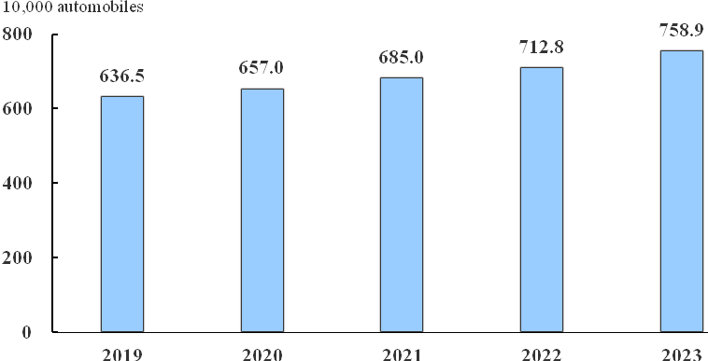
In 2023, the business volume of post services[8] totaled RMB 32.43 billion, up by 15.2% over the previous year on comparable basis. In post services, the business volume of postal letters reached 0.11 billion, and the express delivery business volume reached 2.27 billion, up by 16.1%. In 2023, the business volume of telecommunication services[9] totaled RMB 63.68 billion, up by 15.2% on comparable basis. By the end of 2023, the number of mobile phone base stations had reached 329 thousands, of which, that of 4G base stations totaled 163 thousands, and that of 5G base stations totaled 107 thousands, the number of 5G base stations increased by 31 thousands over the previous year. By the end of 2023, the mobile phone subscribers had totaled 40.211 million, of which, the number of 5G mobile phone subscribers totaled 19.865 million, accounting for 49.4% of the number of mobile phone subscribers; the popularization rate of mobile phone reached 184 sets per 100 persons. By the end of 2023, the number of fixed broadband Internet subscribers had reached 9.334 million, up by 6.4%, of which, the number of Gigabet broadband Internet subscribers reached 2.287 million; mobile Internet access traffic reached 6.61 billion GB, up by 13.0%.
V. Finance
By the end of 2023, the balance of deposits in RMB and foreign currencies in financial institutions of Beijing (including foreign institutions) had registered RMB 24.6 trillion, increasing by 12.7% compared with that at the end of the previous year, of which, the balance of deposits in RMB registered RMB 24.0 trillion, increasing by 13.2%. The balance of loans in RMB and foreign currencies in financial institutions of Beijing (including foreign institutions) hit RMB 11.1 trillion, increasing by 13.0% compared with that at the end of the previous of year, of which, the balance of loans in RMB hit RMB 10.9 trillion, increasing by 13.4%; the household consumer loans in RMB registered RMB 2.0 trillion, increasing by 4.3%. The balance of inclusive loans to micro and small businesses in financial institutions totaled RMB 957.57 billion, increasing by 23.0% comparing with that at the end of the previous year.
Table 9: Deposit and Loan Balance in RMB and Foreign Currencies in Financial Institutions (Including Foreign Institutions) at the End of 2023
Unit: RMB 100 million
Indicators | Year-end figure | Increased/decreased amount over the year-beginning amount
Total Deposit Balance | 246430.0 | 27968.8
Of which: Deposits in RMB | 240438.6 | 28159.5
Of which: Domestic Deposits | 244476.4 | 28151.7
Of which: Household Deposits | 65809.3 | 7190.7
Non-financial enterprise Deposits | 75984.9 | 5125.4
Total Loan Balance | 110835.5 | 12711.6
Of which: Loans in RMB | 108601.2 | 12800.2
Of which: Domestic Loans | 108934.2 | 12443.1
Of which: Household Consumption Loans | 19507.6 | 501.8
Of which: Short-term Loans | 31392.6 | 2783.0
Medium-and Long-term Loans | 70052.8 | 7933.5
Notes Financing | 6224.8 | 1577.6
The trading volume of securities in 2023 stood at RMB 211.4 trillion, up by 14.5% over the previous year. Of which, the trading volume of bonds amounted to RMB 162.0 trillion, up by 18.0%; the trading volume of stocks amounted to RMB 39.2 trillion, down by 2.4%; and the trading volume of fund hit RMB 10.0 trillion, up by 44.0%. By the end of 2023, Beijing Stock Exchange owned 239 listed companies, 77 of which were added during the year; the aggregate market value increased to RMB 449.64 billion; the total turnover of stocks transactions in 2023 hit RMB 727.22 billion, up by 2.7 times over the previous year; the cumulative increase of the BSE 50 Component Index in 2023 was 14.9%.
In 2023, revenues from original insurance premium totaled RMB 320.47 billion, up by 16.2% over the previous year. Of which, that from property insurance premium and that from life insurance premium reached RMB 51.79 billion and RMB 268.68 billion respectively, up by 8.1% and 17.9% respectively. The indemnity of various insurances in 2023 amounted to RMB 87.84 billion, up by 13.2%. Of which, that of property insurance and that of life insurance totaled RMB 34.52 billion and RMB 53.32 billion respectively, up by 23.2% and 7.5% respectively.

VI. Investment in Fixed Assets and Real Estate Development
The total investment in fixed assets (excluding rural households) in 2023 increased by 4.9% over the previous year. Of which, infrastructure investment grew by 0.9%. By industries, the investment in the Primary Industry decreased by 45.7%; investment in the Secondary Industry decreased by 1.1%, of which, investment in manufacturing decreased by 1.6%; investment in the Tertiary Industry increased by 6.0%, of which, investment in information transmission, software and information technology services, investment in culture, sports and entertainment, and investment in transport, storage and post increased by 47.1%, 11.4% and 10.1% respectively. The investment in high-tech industry increased by 16.2%, of which, the investment in high-tech service industry increased by 36.1%.
Real estate development investment in 2023 increased by 0.4% over the previous year. Of which, investment in residential buildings increased by 1.7%; investment in offices increased by 19.5%; investment in commercial housing and houses for business use decreased by 19.9%. The construction area of buildings in the city was 125.313 million square meters, down by 6.0% over the previous year. Of which, new started floor space in 2023 amounted to 12.571 million square meters, down by 29.2%. Floor space of buildings completed in 2023 was 20.422 million square meters, up by 5.4%.
Table 10: Main Indicators for Real Estate Development and Sales in 2023
Indicators | Absolute volume (10,000 square meters) | Increase over the previous year (%)
Floor Space of Buildings under Construction | 12531.3 | -6.0
Of which: Residential Buildings | 6255.5 | -6.8
Of which: Floor Space Newly Constructed in  This Year | 1257.1 | -29.2
Of which: Residential Buildings | 715.1 | -26.9
Floor Space of Buildings Completed | 2042.2 | 5.4
Of which: Residential Buildings | 1135.9 | 3.6
Floor Space of Sold Commercial Housings | 1122.6 | 7.9
Of which: Residential Buildings | 811.1 | 9.3
Floor Space of Vacant Commercial Housings at  the Year End | 2949.9 | 12.7
Of which: Residential Buildings | 1063.6 | 24.5
The number of fund-raising government-subsidized rental housing constructed in 2023 totaled 82 thousands suites (units), and the number of completed affordable housing registered 93 thousands suites (units). The number of newly-started residential communities in the project of renovation of old residential communities in the city totaled 355, and the number of newly-finished residential communities totaled 183.
VII. Market Consumption
The total market consumption in 2023 increased by 10.2% over the previous year. Of which, service consumption rose by 14.6%; retail sales of consumer goods totaled RMB 1,446.27 billion, up by 4.8%. Among the retail sales of consumer goods, the wholesale and retail trade above designated size[10] and the accommodation and restaurants above designated size[11] achieved online retail sales of RMB 548.52 billion, down by 2.7%. In wholesale and retail trade above designated size, the retail sales of gold, silver and jewelry, that of sports and recreation goods, and that of clothing, shoes, hats and textiles grew by 35.0%, 29.8% and 23.4% respectively; and the retail sales of automobiles grew by 13.5%, of which, the retail sales of new energy vehicles grew by 38.0%.
Efforts were made to advance the cultivation and construction of Beijing as an international consumption center city. In 2023, the number of newly established enterprises engaged in wholesale and retail, accommodation and restaurants reached 61 thousands, up by 15.6% over the previous year; the number of newly-introduced first stores totaled 946, up by 16.5%; and the number of departure tax refund stores reached 1,058 by the end of 2023, with an increase of 41 over the end of the previous year.
Table 11: Total Retail Sales of Consumer Goods in 2023
Indicators | Total retail sales of consumer goods (RMB 100 million) | Increase over the previous year (%)
Total | 14462.7 | 4.8
Grouped by Use
Eating | 3153.3 | 9.4
Clothing | 780.9 | 18.2
Daily Use | 9910.2 | 2.3
Fuels | 618.3 | 9.1
Grouped by Consumption Pattern
Catering Revenue | 1314.6 | 32.5
Commodity Retail Revenue | 13148.1 | 2.7

Figure 5: Total Retail Sales of Consumer Goods and Growth Rates from 2019 to 2023
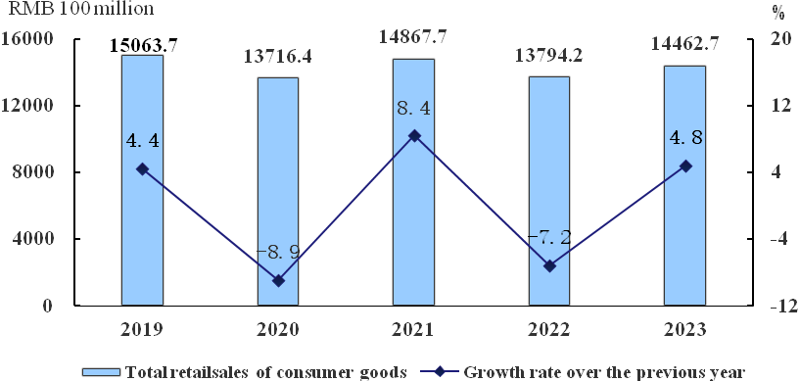

VIII. External Economic Relations
Total imports and exports of Beijing in 2023 amounted to RMB 3,646.63 billion, up by 0.3% over the previous year. Of which, imports hit RMB 3,046.63 billion, remaining the same as that of the previous year; exports totaled RMB 600.01 billion, up by 2.0%. Total imports and exports of Beijing with countries involved in BRI cooperation registered RMB 1,922.20 billion, accounting for 52.7% of the total imports and exports of Beijing.
Figure 6: Total Value of Imports and Exports from 2019 to 2023
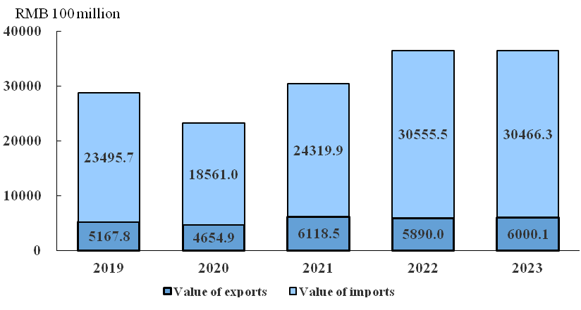
In 2023, the number of newly established foreign-funded enterprises totaled 1,729, up by 22.8% over the previous year. Foreign direct investment in actual use amounted to USD 13.71 billion, down by 21.2%. Of which, the amount used in the sector of scientific research and development, technical services totaled USD 5.81 billion, accounting for 42.4%; the amount used in the sector of information transmission, software and information technology services totaled USD 3.25 billion, accounting for 23.7%; and the amount used in the sector of renting and leasing activities and business services totaled USD 2.30 billion, accounting for 16.8%.
Table 12: Foreign Direct Investment in Actual Use by Some Sectors in 2023
Sectors | Amount  (USD 10,000) | Proportion (%)
Total | 1371411 | 100.0
Of which: Manufacturing | 39143 | 2.9
Wholesale and Retail Trades | 16748 | 1.2
Transportation, Storage and Post | 158 | 0.01
Information Transmission, Software  and Information Technology Services | 324753 | 23.7
Finance | 108383 | 7.9
Real Estate | 22815 | 1.7
Renting and Leasing Activities and  Business Services | 229864 | 16.8
Scientific Research and Development,  Technical Services | 580990 | 42.4
In 2023, the non-financial outward foreign direct investment by enterprises reached USD 8.13 billion, up by 17.4% over the previous year, of which, the direct investment in the countries involved in the BRI cooperation amounted to USD 0.60 billion.
In 2023, the turnover of contracted foreign projects was USD 5.23 billion. A total of 25 thousands laborers of various types were dispatched for foreign labor cooperation, and the actual income of the laborers totaled USD 0.52 billion.
The construction of “Two Zones”[12] was thoroughly promoted. In the key industries where further opening up was carried out in the service sector, the number of newly established foreign-funded enterprises in scientific research and development, technical services, in renting and leasing activities and business services, and in culture, sports and entertainment totaled 1,321, accounting for 76.4% of the newly established foreign-funded enterprises of the city; the operating revenue of foreign-funded enterprises above designated size in the sector of information transmission, software and information technology services, the sector of culture, sports and entertainment, and the sector of health care and social works grew rapidly, up by 53.4%, 39.7% and 34.9% respectively over the previous year. 258 new foreign-funded enterprises were established in China (Beijing) Pilot Free Trade Zone (hereinafter referred to as the Pilot Free Trade Zone), accounting for 14.9% of the number of newly established foreign-funded enterprises of the city; the realized operating revenue of foreign-funded enterprises above designated size in Pilot Free Trade Zone amounted to RMB 2.1 trillion, up by 6.5% over the previous year, accounting for 33.7% of the revenue of foreign-funded enterprises of the city; total imports and exports of the Pilot Free Trade Zone amounted to RMB 462.43 billion, up by 2.7%, accounting for 12.7% of the total imports and exports of Beijing.

IX. Urban Construction and Safety Production
At the end of 2023, length of highways in Beijing totaled 22,433.2 km, with an increase of 70.4 km over the end of the previous year. Of which, the length of expressways reached 1,211.1 km, with an increase of 14.8 km. Total length of urban roads by the end of 2023 reached 6,256 km, with an increase of 47 km over the end of the previous year.
At the end of 2023, public transportation lines totaled 1,285, with a decrease of 6 lines over the end of the previous year. Length of lines in operation registered 29,738.5 km, with a decrease of 435.4 km. Vehicles in operation totaled 23,385, with a decrease of 80. Passenger capacity in 2023 totaled 2.09 billion person-times, up by 20.9%. Subway lines in operation by the end of 2023 amounted to 27, remaining the same as that of the previous year. Length of lines in operation was 836 km, with an increase of 38.7 km. Vehicles in operation totaled 7,512, with an increase of 238. Passenger capacity in 2023 totaled 3.45 billion person-times, up by 52.6%.
At the end of 2023, shared bicycles totaled 916 thousands, with an increase of 35 thousands over the end of the previous year.
Sales volume of tap water in 2023 amounted to 1.33 billion cubic meters, up by 7.8% over the previous year. Of which, that of water for industrial consumption and construction industry totaled 0.11 billion cubic meters, up by 2.0%; that of water for public services amounted to 0.48 billion cubic meters, up by 11.5%; that of water for households use hit 0.71 billion cubic meters, up by 6.6%.
Electricity consumption in Beijing totaled 135.78 billion KWH in 2023, with an increase of 6.0% over the previous year. Of which, the consumption for production amounted to 102.32 billion KWH, up by 6.6%; that for households in urban and rural areas reached 33.46 billion KWH, up by 4.3%.
In 2023, total supply of natural gas[13] stood at 20.61 billion cubic meters, up by 3.5% over the previous year; total supply of liquefied petroleum gas stood at 123 thousands tons, down by 21.5%. By the end of 2023, a total of 9.942 million households had gained access to gas supply, up by 2.1%; of which, 7.805 million households had access to natural gas supply, up by 3.6%. By the end of 2023, total length of gas pipelines reached 33,219 km, up by 5.1%.
Centralized heating area covering over 0.1 million square meters in Beijing totaled 703 million square meters, up by 2.4% over the previous year.
A total of 401 fatal accidents related to production safety occurred in 2023, which caused 440 deaths. Death rate in accidents related to production safety[14] per unit of GDP stood at 1.0055 persons / RMB 10 billion.

X. People’s Living Conditions and Social Security
In 2023, the per capita disposable income of residents in Beijing reached RMB 81,752, up by 5.6% over the previous year, and up by 5.2% in real term after adjusting for inflation. In terms of the four items of income composition, the per capita wage income of residents was RMB 51,632, with an increase of 8.1%; the per capita net operating income was RMB 1,026, with an increase of 13.6%; the per capita net property income was RMB 12,280, with a decrease of 1.1%; and the per capita net transfer income was RMB 16,814, with an increase of 2.9%. The per capita disposal income of urban residents reached RMB 88,650, up by 5.5% over the previous year, and that of rural residents reached RMB 37,358, up by 7.5%. The ratio of per capita disposal income between urban and rural residents was 2.37, being 0.05 lower than that in the previous year.
In 2023, the per capita consumption expenditure of residents in Beijing hit RMB 47,586, up by 11.5% over the previous year, of which, the per capita consumption expenditure of urban residents was RMB 50,897, up by 11.6%, and that of rural residents was RMB 26,277, up by 10.7%. The Engel coefficient of residents in Beijing was 21.3%, of which, that of urban residents was 20.8%, and that of rural residents was 27.8%.
Figure 7: Per Capita Disposable Income of Residents in Beijing and the Growth Rates from 2019 to 2023
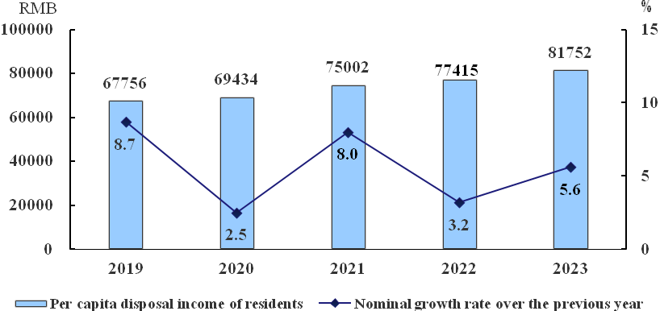
Figure 8: Per Capita Consumption Expenditure of Residents in Beijing and the Composition in 2023
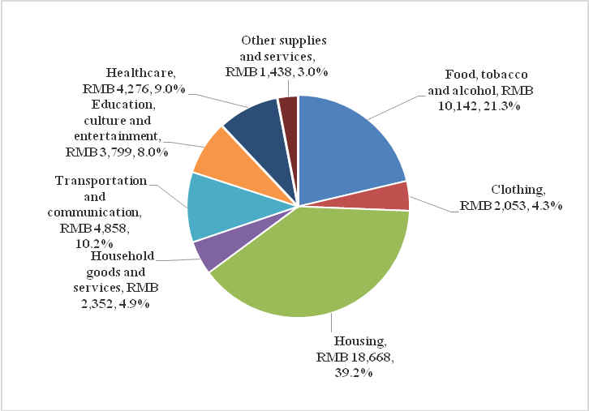
By the end of 2023, the number of people participating in basic pension insurance, unemployment insurance and employment injury insurance for enterprise staff registered 18.015 million, 14.184 million and 13.639 million respectively, increasing by 368 thousands, 27 thousands and 269 thousands respectively over the end of the previous year; the number of people participating in basic medical care insurance and maternity insurance for urban employees registered 15.047 million and 10.708 million respectively. By the end of 2023, people participating in basic pension insurance designed for urban and rural residents hit 1.803 million, and the number of people participating in basic medical care insurance for urban and rural residents amounted to 4.005 million. By the end of 2023, the number of people receiving the minimum living allowance in urban area amounted to 69 thousands, and the number of people receiving the minimum living allowance in rural area amounted to 35 thousands.
Table 13: Social Welfare Standard in 2023
Unit: RMB/month
Indicators | 2023
Minimum Standard for Unemployment Insurance Benefits | 2124
Minimum Living Allowance Standard for Urban and Rural Residents | 1395
Monthly Minimum Wage Standard | 2420
By the end of 2023, there were a total of 618 civil affairs service agencies providing accommodation, with 111 thousands beds and a total of 44 thousands people in hospital. By the end of 2023, the cumulative number of elderly dining service centers totaled 1,772, including 1,246 elderly service agencies, 341 social catering enterprises, and 185 elderly dining tables and unit canteens, covering 4,988 urban and rural communities and over 2.80 million people.

XI. Science and Technology, and Education
The construction of the International Center for Science & Technology Innovation was advanced. From January to November, the costs of research and development of large and medium-sized key enterprises above designated size totaled RMB 350.11 billion, with a year-on-year growth of 4.6%. By sectors, the costs of research and development of industrial enterprises amounted to RMB 54.4 billion, up by 11.5%; that of the sector of information transmission, software and information technology services amounted to RMB 258.33 billion, up by 2.1%; and that of the sector of scientific research and development, technical services amounted to RMB 37.38 billion, up by 14.2%. As the main platform for construction of Beijing International Center for Science & Technology Innovation, the costs of research and development of large and medium-sized key enterprises in “Zhongguancun Science City, Huairou Science City, Future City of Science, and Beijing Economic-Technological Development Area” totaled RMB 242.98 billion, with a year-on-year growth of 4.8%, accounting for 69.4% of the costs of research and development of large and medium-sized key enterprises of the city.
By the end of 2023, the number of the national key laboratories in Beijing totaled 77, accounting for 28.1% of that throughout the country. The National Science and Technology Achievement Transformation Guidance Fund set up four sub-funds, with a total fund size of RMB 6.44 billion. By the end of 2023, there were a total of 71 national-level science and technology business incubators and 145 national registered maker spaces in Beijing. In 2023, 10.8 thousands national high-tech enterprises were newly recognized, and the cumulative number of effective national high-tech enterprises totaled 28.3 thousands. By the end of 2023, a total of 7,180 municipal-level “specialized and new” small and medium-sized enterprises were recognized, including 795 national-level specialized and new “little giants”. By the end of 2023, there were a total of 114 unicorn companies, with an estimated market value of USD 521.50 billion.
In 2023, the number of patent authorization amounted to 108 thousands, with a rise of 22.4% over the previous year. By the end of 2023, the total number of patents for invention in force was 574 thousands, up by 20.2%. The number of application related to PCT international patent amounted to 11,438. The number of high-value invention patent ownership per 10,000 persons was 136.95, with an increase of 24.97. A total of 106,552 technology contracts were recognized and registered in 2023, up by 12.1%. The total turnover of technology contracts achieved RMB 853.69 billion, up by 7.4%; a total of 6,758 technology contracts flowed from Beijing to Tianjin and Hebei, up by 14.9%, with total turnover of RMB 74.87 billion, growing by 1.1 times. The super-large scale intelligent model “Wudao 3.0” made a breakthrough in language and vision multimodality, and a number of major innovation achievements emerged, including the new generation quantum computing cloud platform – “Quafu”, the new generation 256-core blockchain acceleration chip, the first Embodied Generalist Agent excelling in 3D World Tasks – “LEO”, and “Zhuque-2”, namely the world’s first methane-liquid oxygen carrier rocket successfully placed into the orbit.
In 2023, there were 152 thousands students enrolled for postgraduate education, 455 thousands postgraduates and 121 thousands graduates. A total of 176 thousands students were enrolled by universities and junior colleges in Beijing and number of non-graduating students and graduates registered 618 thousands and 154 thousands respectively. As for universities and junior colleges for adults, newly enrolled students, non-graduating students and graduates amounted to 30 thousands, 76 thousands and 30 thousands respectively. Various secondary vocational schools (excluding technical schools) enrolled 21 thousands students, with non-graduating students of 59 thousands and graduates of 16 thousands. The number of enrolled students, non-graduating students and graduates in high schools of Beijing amounted to 80 thousands, 217 thousands and 59 thousands respectively. Number of enrolled students, non-graduating students and graduates in middle schools registered 135 thousands, 371 thousands and 110 thousands respectively. That in primary schools hit 235 thousands, 1,162 thousands and 146 thousands respectively. Special education schools enrolled 1,296 students, with non-graduating students of 7,825 and graduates of 1,788. Number of enrolled children and existing children in kindergartens reached 164 thousands and 515 thousands respectively. In 2023, there were a total of 15 private colleges and universities with non-graduating students of 57 thousands; private middle schools (excluding technical schools) amounted to 125 with non-graduating students of 29 thousands; and private primary schools totaled 38 with non-graduating students of 38 thousands. Private kindergarten reached 1,045 with existing children of 213 thousands.

XII. Culture and Tourism, Public Health and Sports
By the end of 2023, there were a total of 20 public libraries (including National Library of China) with a total number of visitors of 18.825 million person-times. National archives totaled 18 with 11.688 million of paper archives. Filed museums amounted to 226 with 107 open for free. Cultural centers amounted to 18, and cultural stations amounted to 339. In Beijing, the total number of newspapers and periodicals registered 3,516; the number of publishing houses was 223; the number of publication issuing units was 11,007; the number of publication copyright introduced was 6,322; and the number of copyright registered 1.101 million. By the end of 2023, the actual number of cable television subscribers reached 6.14 million, of which, the actual number of HD television subscribers amounted to 3.25 million and the actual number of ultra HD (4K) television subscribers amounted to 2.13 million. 28 TV series of 872 episodes, 157 documentaries, 39 web series, 60 Internet movies, 102 web mini-plays and 38 web cartoon programs were produced in 2023. 144 films were produced throughout the year; there were 309 cinemas under 30 theater chains, showing films for 3.38 million times and attracting audience of 50.409 million person-times, which gained box office earnings of RMB 2.77 billion. In 2023, a total of 49,524 performances were held in 339 performance venues[15], with an increase of 1.4 times over the previous year; the number of audience totaled 11.385 million person-times, with an increase of 2 times; the total performance income amounted to RMB 2.30 billion, with an increase of 2.7 times. The total realized income of legal entities of cultural and related industry above designated size in Beijing registered RMB 2,063.83 billion, up by 13.6% over the previous year.
In 2023, total number of tourists reached 0.329 billion person-times, up by 80.2% over the previous year; total income of tourism reached RMB 584.97 billion, up by 1.3 times. Of which, total number of domestic tourists reached 0.327 billion person-times, up by 79.8%; total income from domestic tourism realized RMB 573.12 billion, up by 1.3 times. Number of inbound tourists registered 1.168 million person-times, up by 3.8 times. Foreign exchange income from foreign tourism totaled USD 1.66 billion, up by 2.8 times. Total number of tourists for outbound tourism organized by travel agencies reached 363 thousands person-times.
By the end of 2023, there were 12,518 medical and health institutions[16] in Beijing, with an increase of 307 over the end of the previous year. Of which, hospitals totaled 765. There were 139 thousands beds in medical and health institutions, with an increase of 5 thousands. Of which, beds in hospitals amounted to 131 thousands. The number of health technical personnel was 343 thousands; of which, the number of practicing (assistant) doctors and registered nurses reached 134 thousands and 153 thousands respectively. 290.881 million person-times of diagnosis and treatment were done by medical institutions.
In 2023, a total of 43 national fitness demonstration sub-districts and sports characteristic towns were created, 14 sports parks were reconstructed and expanded, and 82 new sports and fitness venues for football, basketball, etc. were built. In 2023, 58 medals were won in international competitions by Beijing athletes, including 34 gold medals, 12 silver medals and 12 copper medals; 180 medals were won in national competitions, of which, gold medals, silver medals and copper medals amounted to 62, 56 and 62 respectively. In 2023, 87 medals were won in international competitions by athletes with disabilities from Beijing, including 36 gold medals, 30 silver medals and 21 copper medals; 16 medals were won in national competitions, of which gold medals, silver medals and copper medals amounted to 5, 5 and 6 respectively.

XIII. Resources and Urban Environment
Total supply of lands for construction use in Beijing in 2023 was 4,760 hectares. Of which, the supply of construction lands for special use and for transport and water conservancy use[17] was 2,411 hectares, the supply of lands for public administration and public services was 691 hectares, the supply of residential lands was 1,147 hectares, and the supply of industrial lands was 511 hectares.
In 2023, total stock of water resources hit 4.160 billion cubic meters. By the end of 2023, large and medium-sized reservoirs achieved a total stock of 3.742 billion cubic meters of water, 0.064 billion cubic meters less than that at the end of the previous year. By the end of 2023, burial depth of groundwater of plain areas[18] was 14.74 meters, up by 0.9 meters over the end of the previous year. Total water consumption for production and living purpose in 2023 reached 2.527 billion cubic meters, increasing by 2.8%. Of which, consumption for living purpose (including water for public services and for households use) stood at 1.661 billion cubic meters with a rise of 2.5%; among the water consumption for production purpose, water consumption for agricultural use amounted to 0.251 billion cubic meters with a drop of 3.7% and that for industrial use hit 0.268 billion cubic meters with a rise of 16.6%.
In 2023, the treatment rate of urban sewage stood at 97.3%, showing an increase of 0.3 percentage points over the previous year; of which, the treatment rate of urban sewage in six districts (Dongcheng District, Xicheng District, Chaoyang District, Haidian District, Fengtai District and Shijingshan District) reached 99.7%, remaining the same as that in the previous year. A total of 7.5885 million tons of household garbage in Beijing were removed, transported and disposed, an average of 20.8 thousands tons per day. Of which, the other garbage totaled 5.6685 million tons, an average of 15.5 thousands tons per day; and the kitchen garbage totaled 1.92 million tons, an average of 5.3 thousands tons per day. There were a total of 34 centralized disposal facilities for household garbage in Beijing, with actual disposal capacity of 28,426 tons per day.
The four major pollutants in the atmosphere environment in Beijing reached the national secondary standard for air quality continuously and steadily. Of which, the average annual concentration of fine particles (PM_{2.5}), inspiratory particulate matter (PM₁₀), nitrogen dioxide (NO₂) and sulfur dioxide (SO₂) was 32 μg/m³, 61 μg/m³, 26 μg/m³ and 3 μg/m³ respectively. A total of 1,000 hectares of afforestation were increased in 2023 (including the reafforestation of land greening project). Forest coverage rate was 44.9%. The green coverage ratio in urban regions of Beijing stood at 49.8%, and the per-capita green area in public parks was 16.9 m².
Figure 9: Average Annual Concentration of Fine Particles (PM_{2.5}) from 2019 to 2023
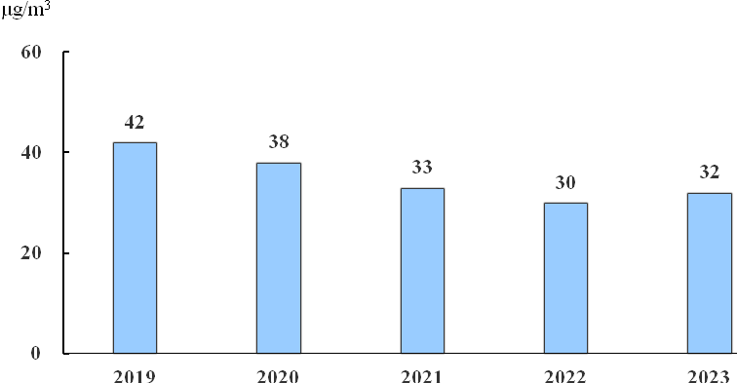
Figure 10: Green Coverage Ratio in Urban Regions from 2019 to 2023
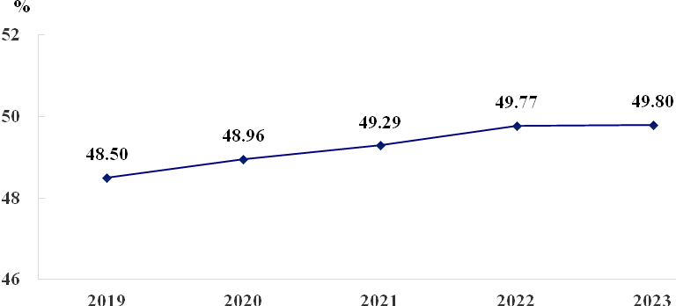

Notes:

[1]All data of 2023 is from the result of preliminary statistics. No mechanical adjustment is made to the statistical discrepancies on part of total or relative figures that are caused by different measurement units.
[2]The classification of three industries is based on the Regulations on Three Industries Classification (G.T.Z. [2018] No. 74) revised by the National Bureau of Statistics in 2018; the classification of sectors is based on the Classification of National Economic Sectors (GB/T4754-2017).
[3] The data of permanent population in 2023 is estimated through sample survey on population change in 2023 organized and conducted throughout the country in a unified manner, and the standard time point of survey is at 00:00 on November 1, 2023.
[4]The key leading enterprises of agricultural industrialization in Beijing refer to enterprises that take production, processing, circulation or services of agricultural products as their main businesses, have direct and close contacts with farmers through contracts, cooperation, joint stock cooperation and other benefit linkage models, conform to the functional orientation of Beijing, meet the needs of urban agriculture development, reach the required standards in terms of business scale, performance of enterprise, radiation driving capacity, etc. and are approved by the Joint Conference on Agricultural Industrialization in Beijing
[5]Green food enterprises engaged in local agricultural products within the validity period refer to Beijing agricultural products production enterprises that have obtained the right to use the green food mark and are within the three-year validity period.
[6]Industrial enterprises above designated size refer to all industrial legal person enterprises with annual main business revenue of RMB 20 million and above.
[7]Manufacture of five major equipment covers five sectors including manufacture of general-purpose machinery, manufacture of special-purpose machinery, manufacture of railway locomotives, building of ships and boats, manufacture of air and spacecrafts and other transportation equipments, manufacture of electrical machinery and equipment, and manufacture of measuring instrument and meter.
[8] Business volume of post services is calculated based on the constant price of 2020.
[9]Business volume of telecommunications services of telecommunications enterprises are calculated based on the constant price of the previous year.
[10]Wholesale and retail units above designated size refer to the wholesale units with annual main business revenue of RMB 20 million and above, and retail units with annual main business revenue of RMB 5 million and above (including legal entities, industrial activities units and self-employed households).
[11]Accommodation and restaurants units above designated size refer to the accommodation units whose annual main business revenue reaches RMB 2 million and above, and the restaurants units whose annual main business revenue amounts to RMB 2 million and above (including legal entities, industrial activities units and self-employed households).
[12]“Two Zones” refer to the Integrated National Demonstration Zone for Opening up the Service Sector and China (Beijing) Pilot Free Trade Zone.
[13]The total supply of natural gas includes the supply of SINOPEC Beijing Yanshan Company.
[14]Accidents related to production safety are counted according to the seven categories including mining, commercial and trade, road transportation, railway, fire connected with production and operation, agricultural machinery, special equipment and civil aircraft.
[15]The scope of statistics of the operation of art performance venues covers the key art performance venues in Beijing that provide professional performance venues and services for performance activities, and the key performance units that engage in artistic performance activities.
[16]The data of medical institutions and health technical personnel includes that of Beijing troops and armed police hospitals and excludes data of beds.
[17]Construction lands for special use and for transport and water conservancy use refer to the specially-designated lands, lands for transport use, and lands for waters and water conservancy facilities.
[18]Burial depth of underground water in plain area means the distance between the underground water level and the ground level of the plain area. Source of Statistics: Statistics on the construction of Beijing Municipal Administrative Center are from Beijing Municipal Administrative Center Party Working Committee and Management Committee; fiscal statistics are from Beijing Municipal Finance Bureau; tax statistics are from Beijing Municipal Tax Service, State Taxation Administration; statistics on newly established enterprises are from Beijing Municipal Administration for Market Regulation; statistics on electricity generation and use are from State Grid Beijing Electric Power Company; statistics on agricultural modernization and rural revitalization are from Beijing Municipal Bureau of Agriculture and Rural Affairs; statistics on motor vehicles are from Beijing Traffic Management Bureau; statistics on mobile phone 5G base stations and subscribers as well as the Gigabet fixed Internet subscribers are from Beijing Communications Administration; statistics on deposits and loans are from Beijing Branch of the People’s Bank of China; statistics on securities turnover are from Shanghai Stock Exchange and Shenzhen Stock Exchange; statistics on Beijing Stock Exchange are from the official website of Beijing Stock Exchange; statistics on insurance are from Beijing Office of National Financial Regulatory Administration; statistics on government-subsidized housing and renovation of old residential communities are from Beijing Municipal Commission of Housing and Urban-Rural Development; statistics on newly-introduced first stores, departure tax refund stores, foreign investment in actual use, overseas investment, contracted foreign projects and foreign labor cooperation are from Beijing Municipal Commerce Bureau; statistics on import and export are from Beijing Customs District P.R. China; statistics on road construction and public transportation are from Beijing Municipal Commission of Transport; statistics on tap water sales, water resources and urban sewage treatment are from Beijing Water Authority; statistics on liquefied petroleum gas and natural gas supply, gas-accessed households, gas pipelines and areas covered by centralized heating and garbage disposal are from Beijing Municipal Commission of Urban Management; statistics on safety production are from Beijing Emergency Management Bureau; statistics on medical insurance and maternity insurance are from Beijing Municipal Medical Insurance Bureau; statistics on other social security and newly increased urban employment are from Beijing Municipal Human Resources and Social Security Bureau; statistics on subsistence allowance, agencies providing accommodation, and elderly dining services are from Beijing Municipal Civil Affairs Bureau; statistics on National Technology Achievement Transformation Guiding Fund are from National Science and Technology Venture Capital Development Center under the Ministry of Science and Technology; statistics on national key laboratories, national-level science and technology business incubators, national registered maker spaces, national high-tech enterprises, unicorn enterprises and technology market are from Beijing Municipal Science & Technology Commission, Administrative Commission of Zhongguancun Science Park; statistics on “specialized and new” enterprises are from Beijing Municipal Bureau of Economy and Information Technology; statistics on patents are from Beijing Municipal Intellectual Property Office; statistics on education are from Beijing Municipal Education Commission; statistics on public libraries, cultural centers, performance venues and tourism, are from Beijing Municipal Bureau of Culture and Tourism and National Library of China; statistics on archives are from Beijing Municipal Bureau of Archives; statistics on museums are from Beijing Municipal Cultural Heritage Bureau; statistics on publication are from Beijing Municipal Bureau of Press and Publication; statistics on television are from Beijing Municipal Radio and Television Bureau; statistics on films are from Beijing Municipal Film Administration; statistics on healthcare are from Beijing Municipal Health Commission; statistics on national fitness and athletes are from Beijing Municipal Bureau of Sports; statistics on athletes with disabilities are from Beijing Disabled Persons’ Federation; statistics on construction land supply are from Beijing Municipal Commission of Planning and Natural Resources; statistics on air quality are from Beijing Municipal Ecology and Environment Bureau; statistics on afforestation and landscaping are from Beijing Municipal Forestry and Parks Bureau; other statistics are from Beijing Municipal Bureau of Statistics and NBS Survey Office in Beijing.

